**CONTROLLING DC FAN USING MICROPROCESSOR**

Hardware Design and Assembly Level Programme

Report is completed in partial fulfilment of the course

**Microprocessor Programming and Interfacing (CS F241)**



Team Members:

1. Abhishek V Joshi – 2015A7PS116P
2. Ananyashree Garg – 2015A7PS117P
3. Anand Chordia – 2015A7PS118P
4. Karri Venkat Reddy – 2015A7PS119P

**Problem Statement:**

Description: This system senses the speed at which the fan is rotating and adjusts the speed, based on the user input. The user can select three different speeds of the fan. The current speed should be sensed and the control mechanism should gradually increase the speed to the desired speed.

User Interface:

1. Fan starts when user presses ‘Start’ button.

2. User can then set the required speed by using a keypad interface. This speed value should be displayed on the display.

3. After setting speed initially, user should be able to change the fan speed setting by an up and down switch. Each press on this arrow button increases/ decreases the speed by 1 unit. Min speed

value is 1, whereas maximum speed value is 5 Units. Pressing ‘UP’ button after reaching to value.

5, should not change the display value or setting of fan speed. Same is true for lower bound.

4. Fan can be stopped by pressing ‘Stop’ button.

5. User can also set the mode of fan as ‘Auto’ mode besides a ‘Regular mode’ setting. In Auto mode, user should be able to enter the value of time in terms of hours after which the Fan

has to be switched off automatically. (For example, if value entered is 2, then the Fan should switch off after 2 hours from the time this setting is applied

**Assumptions:**

1. CLK pin of the micro-processor is connected to a reliable clock generator to produce waveform of suitable frequency.
2. User can start the fan only by pressing the start button. No other key will function until the fan has been started.
3. The fan starts at speed 1 on press of the start button.
4. Pressing the start button after the fan has started results in no change of the system state.
5. User can then set the speed of the fan by pressing any of the push buttons numbered from 1 to 5.
6. Pressing button number 0 essentially serves the same purpose as that of the stop button.
7. Auto mode runs only at one speed. (Speed 3)
8. Hours in the Auto Mode have been scaled down to Seconds for the sake of simplicity of demonstration.
9. Display doesn’t change when working in the auto mode.

10)Auto mode allows users to enter numbers from 0 to 10.

**List of Hardware Used:**

1. 8086 Micro-Processor = 1
2. 74LS373 Octal Latches = 3
3. 74LS138 3:8 Decoder = 1
4. 8255A Programmable Peripheral Interfacing Device = 1
5. 7SEG-COM-CAT-BLUE Display = 1
6. DAC_8 Digital to Analog Converter = 1
7. DC Fan = 1
8. Push Button Switches = 16
9. 74LS245 Bi-Directional Buffer = 2
10. 2732 SROM Chips (2KB each) = 2
11. 6116 RAM Chips (2KB each) = 2
12. OR Gates = 6
13. NOT Gates = 3
14. SPDT Switch = 1
15. Ground Terminal = as required
16. DC Voltage Sources = as required

**Memory Addressing:**

|  |  |  |
| --- | --- | --- |
| **Item** | **Address** | **Details** |
| RAM (Memory) | 02000H – 02FFFFH | 2 * 2 KB Chips |
| ROM (Memory) | 00000H – 1FFFFH | 2 * 2 KB Chips |
| Port A (8255A) | 00H | Output (DC Fan) |
| Port B (8255A) | 02H | Output (7 Segment Display) |
| Port C (8255A) | 04H | Input/Output (Keypad) |
| Control Register | 06H | For loading the Control Word |

**Flow Chart:**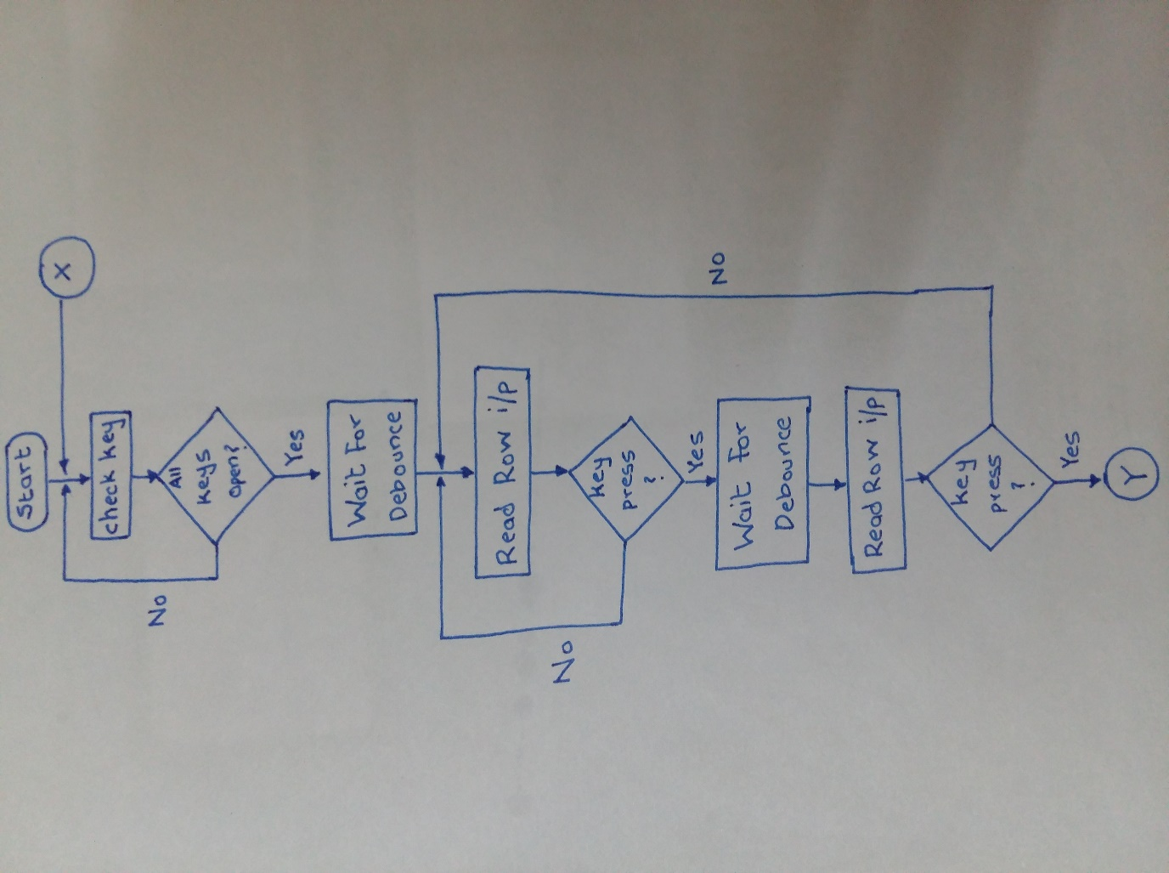

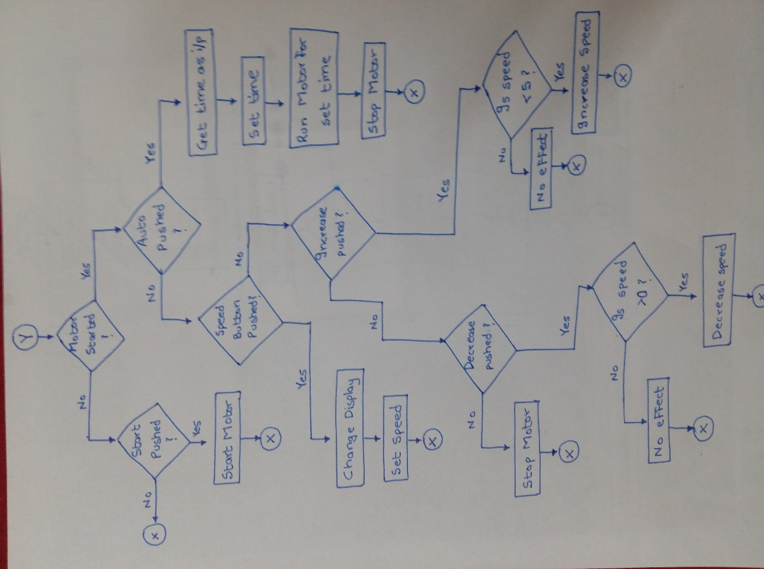

**CODE:**

.model tiny

.data

table_kbrd dw 0eeh, 0edh, 0ebh, 0e7h, 0deh, 0ddh, 0dbh, 0d7h, 0beh, 0bdh, 0bbh, 0b7h, 7eh, 7dh, 7bh, 77h

table_dis db 3fh, 06h, 5bh, 4fh, 66h, 6dh;, 007dh, 0027h, 007fh, 006fh, 0077h, 007ch, 0039h, 005eh, 0079h, 0071h

speed dw 00h

started dw 00h

auto_speed dw 03h

time dw 00h

auto_flag dw 00h

.code

.startup

porta equ 00h ;setting the 8253a ports

portb equ 02h

portc equ 04h

creg equ 06h

;initializing the ports of 8253a

mov al, 88h

out creg, al

x0: mov al, 00h

out portc, al

x1: in al, portc

and al, 0f0h

cmp al, 0f0h ;check for key release

jnz x1

call delay_20ms ;debounce

mov al, 00h

out portc, al

x2: in al, portc

and al, 0f0h

cmp al, 0f0h

jz x2

call delay_20ms ;debounce

;checking the validity of key press

mov al, 00h

out portc, al

in al, portc

and al, 0f0h

cmp al, 0f0h

jz x2

;check for key press column 1

mov al, 0eh

mov bl, al

out portc, al

in al, portc

and al, 0f0h

cmp al, 0f0h

jnz x3

;check for key press column 2

mov al, 0dh

mov bl, al

out portc, al

in al, portc

and al, 0f0h

cmp al, 0f0h

jnz x3

;check for key press column 3

mov al, 0bh

mov bl, al

out portc, al

in al, portc

and al, 0f0h

cmp al, 0f0h

jnz x3

;check for key press column 4

mov al, 07h

mov bl, al

out portc, al

in al, portc

and al, 0f0h

cmp al, 0f0h

jz x2

;decode key

x3: or al, bl

mov cx, 0fh

mov di, 00h

lea di, ds:table_kbrd

x4: cmp al, [di]

jz x5

inc di

loop x4

;checks if motor is started

x5: cmp started, 01h

jz auto

cmp al, 0b7h ;button encoding for start

jz start

jmp x0

start: call start_fan

jmp x0

auto: cmp al, 0b7h

jz x0

cmp auto_flag, 01h

jz time_set

cmp al, 77h

jnz speed_check

mov auto_flag, 01h

jmp x0

time_set: cmp al, 0eeh; checks which speed

call stop

jmp x0

cmp al, 0edh

jz set_time_1

cmp al, 0ebh

jz set_time_2

cmp al, 0e7h

jz set_time_3

cmp al, 0deh

jz set_time_4

cmp al, 0ddh

jz set_time_5

cmp al, 0dbh

jz set_time_6

cmp al, 0d7h

jz set_time_7

cmp al, 0beh

jz set_time_8

cmp al, 0bdh

jz set_time_9

cmp al, 0bbh

jz set_time_10

jmp x0

set_time_1: mov time, 01h

call set_time

call stop

jmp x0

set_time_2: mov time, 02h

call set_time

call stop

jmp x0

set_time_3: mov time, 03h

call set_time

call stop

jmp x0

set_time_4: mov time, 04h

call set_time

call stop

jmp x0

set_time_5: mov time, 05h

call set_time

call stop

jmp x0

set_time_6: mov time, 06h

call set_time

call stop

jmp x0

set_time_7: mov time, 07h

call set_time

call stop

jmp x0

set_time_8: mov time, 08h

call set_time

call stop

jmp x0

set_time_9: mov time, 09h

call set_time

call stop

jmp x0

set_time_10: mov time, 0ah

call set_time

call stop

jmp x0

;checks which speed to set and sets it

speed_check: lea bx, DS:table_dis

cmp al, 0eeh

jz set_speed_0

cmp al, 0edh

jz set_speed_1

cmp al, 0ebh

jz set_speed_2

cmp al, 0e7h

jz set_speed_3

cmp al, 0deh

jz set_speed_4

cmp al, 0ddh

jz set_speed_5

jmp increase

set_speed_0: mov speed, 00h

call stop

mov al, 3fh

not al

out portb, al

jmp x0

set_speed_1: mov speed, 01h

call set_speed

;mov al, 06h

mov al, [bx + 01h]

not al

out portb, al

jmp x0

set_speed_2: mov speed, 02h

call set_speed

;mov al, 5bh

mov al, byteptr[bx + 02h]

not al

out portb, al

jmp x0

set_speed_3: mov speed, 03h

call set_speed

;mov al, 4fh

mov al, byteptr[bx + 03h]

not al

out portb, al

jmp x0

set_speed_4: mov speed, 04h

call set_speed

;mov al, 66h

mov al, byteptr[bx + 04h]

not al

out portb, al

jmp x0

set_speed_5: mov speed, 05h

call set_speed

;mov al, 6dh

mov al, byteptr[bx + 05h]

not al

out portb, al

jmp x0

increase: lea bx, DS:table_dis

cmp al, 7dh

jnz decrease

call incr

call set_speed

jmp x0

decrease: cmp al, 7bh

jnz stop_fan

call decr

call set_speed

jmp x0

stop_fan: cmp al, 7eh

jnz x0

call stop

mov al, 3fh

not al

out portb, al

jmp x0

.exit

;Delay of 20ms

delay_20ms proc near

mov cx, 2220

x9: loop x9

ret

delay_20ms endp

;starts the fan on speed 1 on press of start button

start_fan proc near

mov speed, 01h

mov al, 33h

out porta, al

mov started, 01h

ret

start_fan endp

;stops the fan on press of stop button

stop proc near

mov speed, 00h

mov al, 00h

out porta, al

mov started, 00h

mov auto_flag, 00h

ret

stop endp

;sets the required speed

set_speed proc near

mov cx, speed

mov al, 00h

x: add al, 33h

loop x

out porta, al

ret

set_speed endp

set_time proc near

mov cx, auto_speed

mov al, 00h

x8: add al, 33h

loop x8

out porta, al

mov bx, time

loop3: mov dx, 50

loop2: mov cx, 2220

loop1: nop

dec cx

jnz loop1

dec dx

jnz loop2

dec bx

jnz loop3

ret

set_time endp

incr proc near

cmp speed, 05h

jge x6

inc speed

mov cx, speed

add bx, cx

mov al, [bx]

not al

out portb, al

x6: ret

incr endp

decr proc near

cmp speed, 00h

jbe x7

dec speed

mov cx, speed

add bx, cx

mov al, [bx]

not al

out portb, al

x7: ret

decr endp

end

**Screenshots of the Design:**

